RESOLUTION NO.__________

RE: CERTIFICATE OF APPROPRIATENESS UNDER THE
PROVISIONS OF THE ACT OF THE PENNSYLVANIA
LEGISLATURE 1961, JUNE 13, P.L. 282 (53
SECTION 8004) AND BETHLEHEM ORDINANCE NO.
3952 AS AMENDED.

WHEREAS, it is proposed to install an aluminum sign over the front door and vinyl lettering on the windows and door at 332 E. Third St.

NOW, THEREFORE, BE IT RESOLVED by the Council of the City of Bethlehem that a Certificate of Appropriateness is hereby granted for the work.

Sponsored by: (s)

(s)

ADOPTED BY COUNCIL THIS DAY OF

(s)
President of Council

ATTEST:

(s)
City Clerk

HISTORIC CONSERVATION COMMISSION

CASE # 330 – It is proposed to install an aluminum sign over the front door and vinyl lettering on the windows and door at 332 E. Third St. OWNER: Ashley Development

The Commission upon motion by Ms. Heitmann and seconded by Mr. Loush adopted the proposal that City Council issue a Certificate of Appropriateness for the proposed work described herein:

- The proposal to install an aluminum sign over the front door and vinyl lettering on the windows and door at 332 E. Third St. was presented by Tom Kildriff.

- The new sign will consist of individual letters attached to the storefront fascia and to an aluminum C-Channel also attached to the storefront fascia.

- The sign will read “The Steel Mill Grill & Bar”. “Steel Mill” will be fabricated 1.5” thick stainless steel letters. “The” and “Grill & Bar” will be flat-cut, ½” thick acrylic letters.

- The aluminum C-Chanel will be 12” x 2” and will have a mill finish with a clear powder-coat protective layer. The over-sized bolts that “attach” the channel to the fascia will be HDU foam with silver enamel finish to blend with the aluminum channel

- The restaurant hours will be located on one door only and will be light beige vinyl.

- All holes on the façade from previous signs will be patched and painted.

- A temporary sign may be installed for 4 weeks without HCC approval.

- The Polk St. window signage must be reviewed by the Historic Officer for size.

- The proposed work was approved by a unanimous vote.

CU: cu

By: 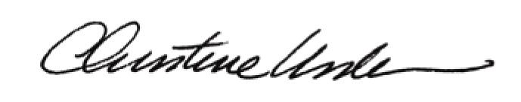

Date of Meeting: March 15, 2010 Title: Historic Officer

